Investment Section Redesign
Sitecore Installation Guide
- Copy Sitecore, Database folder on D drive.
- Copy license.xml to D:\SiteCore\CMSWeb\Data
- Open IIS, Create Virtual Directory ‘CMSXCentium’. (You can use different name)

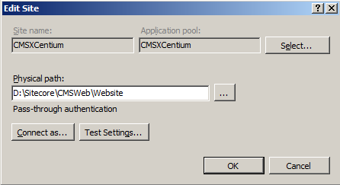

- Set ‘Physical path’ to D:\Sitecore\CMSWeb\Website

- In IIS, Click on ‘Bindings…’ Make sure you are using port 82

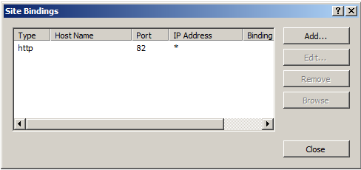

- Make sure you are using correct application pool with correct version of .Net. In this case please refer below screenshot.

- Make sure Microsoft SQL 2012 is installed on machine.

- Restore following databases by using .bak files from ‘Database‘ folder.
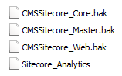

- After Restore, create ‘sitecore’ as database user and give following role access for each database.

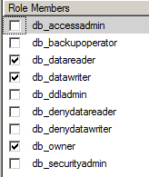

- After database setup please verify connection in ‘ConnectionStrings.config’ file.
File Path: D:\SiteCoreCMSWeb\Website\App_Config\ConnectionStrings.config

- Now we are all set to access website. Use following URL to access website.

localhost:82/en/Investments/Strategies/Strategists/Allocation-Approach.aspx

